### **Marketing Menu**

The Marketing menu provides access tools for managing promotions, communications, SEO, and user-generated content.

[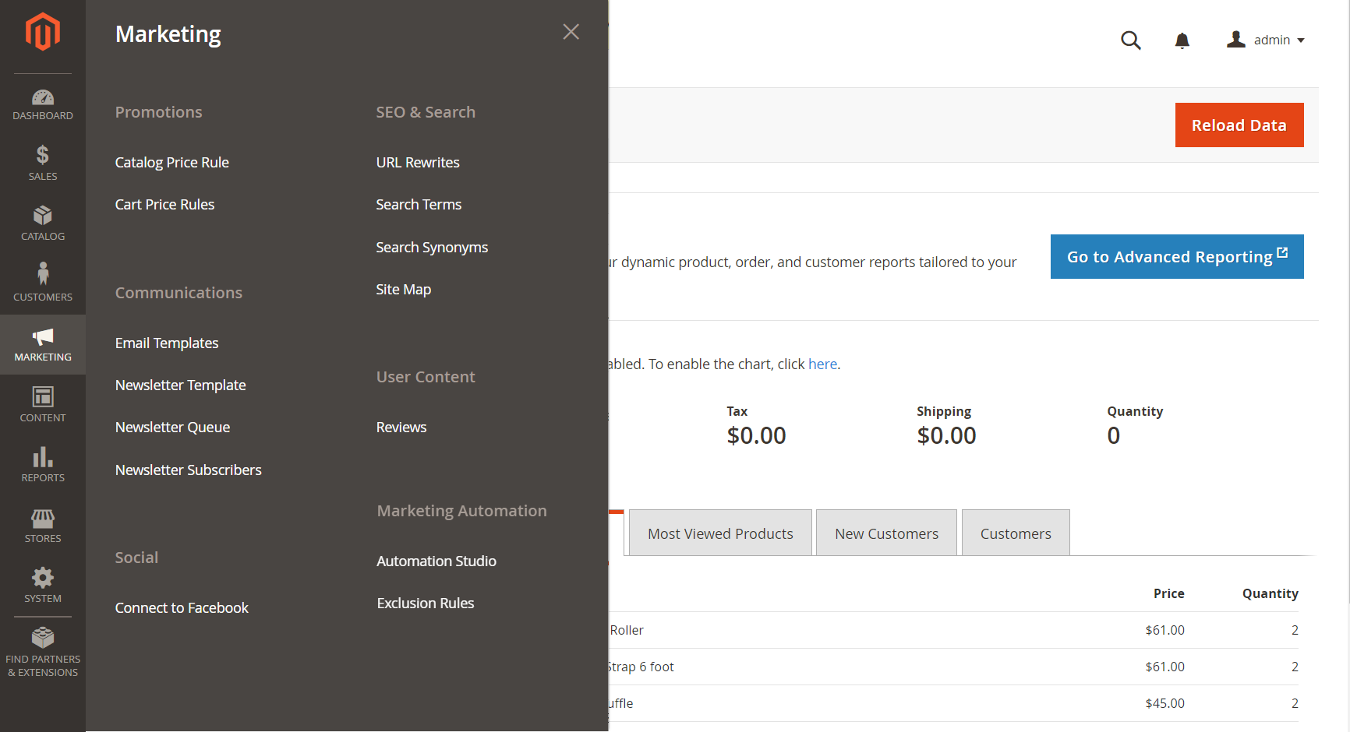](http://docs.magento.com/m2/ce/user_guide/Resources/Images/admin-menu-marketing.png)

**Marketing Menu:** To display the Marketing menu: On the Admin sidebar, tap Marketing.

#### **Main Sections**

[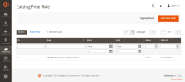](http://docs.magento.com/m2/ce/user_guide/marketing/promotions.html)

## Promotions

Create [catalog](http://docs.magento.com/m2/ce/user_guide/marketing/price-rules-catalog.html) and [cart](http://docs.magento.com/m2/ce/user_guide/marketing/price-rules-cart.html) price rules that trigger discounts based on a variety of conditions. Set up promotions that spring into action when the required conditions are met.

In this section of the guide, you will learn how to set up product relationships, and use price rules to trigger discounts based on a variety of conditions. You can use price rules to offer customer incentives, such as to:

* Send your best customers a coupon for a discount on a specific product
* Offer free shipping for purchases over a certain amount
* Schedule a promotion for a period of time

Cart price rule conditions can be based on any category that is a child of the store’s root. Price rules are set up in advance, and spring into action whenever the required conditions are met.

[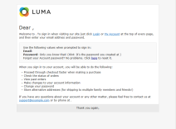](http://docs.magento.com/m2/ce/user_guide/marketing/communications.html)

## Communications

One of the tasks to complete before launching your store is to review the email templates that are used for all communications sent from your store to make sure that they reflect your brand. In this section of the guide, you will learn how to customize email and newsletter templates, as well as PDF invoices and packing slips. You will also learn how to personalize the content with variables and markup tags.

Customize all notifications sent from your store. Create newsletters and publish RSS feeds.

[](http://docs.magento.com/m2/ce/user_guide/marketing/seo-search.html)

[Social](http://docs.magento.com/m2/ce/user_guide/marketing/social.html)

Connect your store to Facebook.

[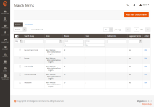](http://docs.magento.com/m2/ce/user_guide/marketing/seo-search.html)

[SEO & Search](http://docs.magento.com/m2/ce/user_guide/marketing/seo-search.html)

Analyze [search terms](http://docs.magento.com/m2/ce/user_guide/marketing/search-terms.html) and [synonyms](http://docs.magento.com/m2/ce/user_guide/marketing/search-synonyms.html) to help customers find products in the store, manage [meta data](http://docs.magento.com/m2/ce/user_guide/marketing/meta-data.html), and create a [site map](http://docs.magento.com/m2/ce/user_guide/marketing/sitemap-xml.html). Use [redirects](http://docs.magento.com/m2/ce/user_guide/marketing/url-rewrite.html) to manage URL changes and avoid broken links.

[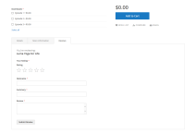](http://docs.magento.com/m2/ce/user_guide/marketing/product-reviews.html)

[User Content](http://docs.magento.com/m2/ce/user_guide/marketing/product-reviews.html)

Leverage user-generated product reviews to create a sense of community, and increase sales.